Loading Data into
OLAP using
For Each Loop Container
&
File System Task

Table of Contents
Introduction 3
Project data flow architecture diagram 3
OLAP (Final F-D model destination) 3
ETL frame work objects(Tables/Procedures/Functions) 4
ETL Frame work tables 4
ETL Frame work procedures 4
ETL Frame work Views 4
[dbo].[SalesvW] 4
ETL Frame work functions 5
[dbo].[DateAndTimeNarration] 5
Important Package variables we use 6
CountriesList variable 6
CurrentCountry variable 6
Timestamp variable 6
RootFolder variable 6
Source and Destination address variable 7
Source Query variable 7
Destination Table variable 7
RootFolder2 variable 7
ProcessedFolder variable 7
Open BatchID 8
ETL Task-1 (AdventureWorksDW2012 to FlatFile ) 8
Open TaskID 9
Mapping steps for Task-1 9
Close TaskID 10
Task-2 (Flat file to OLAP_DB ) 11
Open TaskID 11
Mapping steps for Task-2 11
Close TaskID 12
Close BatchID 12

Introduction
This document will guide you to load the Countries list into Data Warehouse respective Country tables, with step by step guide lines.

Project data flow architecture diagram
We do have the following ETL flow in the project. Namely the staging areas are
- AdventureWorksDW2012 (F-D model RDBMS)
- Files area (Daily refresh data through these files)
- OLAP_DB (Final F-D model destination)

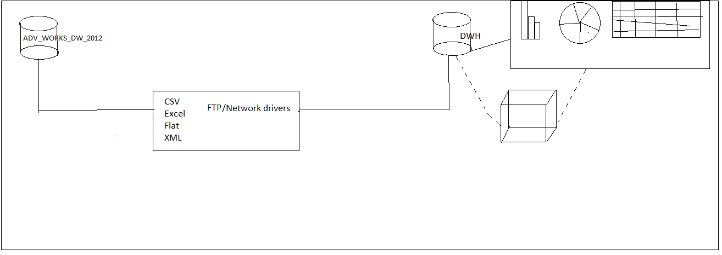

OLAP (Final F-D model destination)
This is our DWH, also final destination. Data will be merged /append from above Dest_Staging to OLAP. Data loading strategy will be INCREMENTAL LOAD.
In our practice model, below is the details about the OLAP

Data Source=VISSU; Initial Catalog=OLAP_DB=SQLNCLI11.1; Integrated Security=SSPI;Auto Translate=False;

ETL frame work objects(Tables/Procedures/Functions)

ETL Frame work tables
Create the destination tables with structures in the OLAP namely Dbo.Australia, Dbo.Canada , Dbo.France, Dbo.Germany , Dbo.UnitedKingdom , Dbo.United States

Script:
SELECT TOP 0 * INTO OLAP_DB.dbo.Australia FROM AdventureWorksDW2012.dbo.SalesVw
SELECT TOP 0 * INTO OLAP_DB.dbo.Canada FROM AdventureWorksDW2012.dbo.SalesVw
SELECT TOP 0 * INTO OLAP_DB.dbo.France FROM AdventureWorksDW2012.dbo.SalesVw
SELECT TOP 0 * INTO OLAP_DB.dbo.Germany FROM AdventureWorksDW2012.dbo.SalesVw
SELECT TOP 0 * INTO OLAP_DB.dbo.[United Kingdom] FROM AdventureWorksDW2012.dbo.SalesVw
SELECT TOP 0 * INTO OLAP_DB.dbo.[United States] FROM AdventureWorksDW2012.dbo.SalesVw

ETL Frame work procedures
Use the InsertSSISBatch2, UpdateSSISBatch2, InsertSSISTask2, UpdateSSISTask2 procedures from the Package10 Design Document.

ETL Frame work Views

[dbo].[SalesvW]
Create a view dbo.SalesvW by joining 5 specified tables from AdventureworksDW2012 from the following script

Script:
CREATE VIEW SalesVw
AS
SELECT
GETDATE() AS LoadedDate
,DD.DateKey
,DD.CalendarYear
,DD.CalendarSemester
,DD.CalendarQuarter
,DD.MonthNumberOfYear
,DD.EnglishMonthName
,DD.FullDateAlternateKey
,DP.ProductKey
,DP.EnglishProductName
,DP.EnglishDescription
,DG.GeographyKey
,DG.EnglishCountryRegionName
,DG.StateProvinceName
,DG.City
,DC.CustomerKey
,DC.FirstName
,DC.LastName
,DC.MiddleName
,DC.Gender
,DC.EmailAddress
,FIS.SalesAmount
,FIS.TaxAmt

FROM [dbo].[FactInternetSales] FIS
INNER JOIN [dbo].[DimCustomer] DC
ON DC.CustomerKey = FIS.CustomerKey
INNER JOIN [dbo].[DimGeography] DG
ON DG.GeographyKey = DC.GeographyKey
INNER JOIN [dbo].[DimProduct] DP
ON FIS.ProductKey = DP.ProductKey
INNER JOIN [dbo].[DimDate] DD
ON DD.DateKey = FIS.OrderDateKey

ETL Frame work functions

[dbo].[DateAndTimeNarration]

This function will accept two arguments (Start & End times), and returns the elapsed time, which helps us to close the audit (Task & Batch) record.
Script:
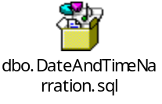

Important Package variables we use
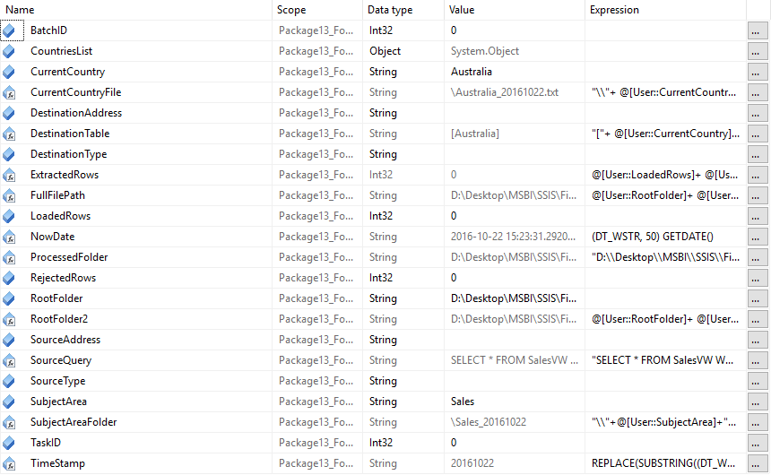

The Variables NowDate , Source Type ,Destination Type,BatchID ,TaskID, ExtractedRows, LoadedRows, RejectedRows are taken from the Package10 Design Document

The remaining variables are defined as following

CountriesList variable
This variable Countries List is Object Data Type. it can be used as variable name in Get list of countries Execute SQL Task and ADO Object source in For Each Loop.

CurrentCountry variable
It is a String variable and defaulted to Australia it can it’s value at runtime in the for each loop container

Timestamp variable
It is string variable evaluated to the current date using the following expression

Expression
REPLACE(SUBSTRING((DT_WSTR, 50) GETDATE(),1,10),"-","")

RootFolder variable
RootFolder is a string type variable and that holds the path of the folder to which the flat files are created andalso processe.
It is static and value as

D:\Desktop\MSBI\SSIS\Files\Flatfiles\DailySalesDetails

Source and Destination address variable
Source address is a string variable that is default null stores the source address. It is evaluated during execution in the script task.
Destination address is a string variable that is default null the stores the destination address. It is evaluated during execution in the script task

Source Query variable
This is a string type variable. This variables evaluates the sql query over the source oledb database using the following expression

Expression

"SELECT * FROM SalesVW WHERE EnglishCountryRegionName = '"+ @[User::CurrentCountry]+"'"

Destination Table variable
This is a string type variable. This variables holds the table name in the destination evaluaed dynamically

"["+ @[User::CurrentCountry]+"]"

RootFolder2 variable
The RootFolder2 is Dynamic variable of String data type that is evaluated from the following expression
Expression:

@[User::RootFolder]+ @[User::SubjectAreaFolder]

ProcessedFolder variable
It is also static variable of sting data type. It is used to move sales data that is generated today is processed(moved) to that folder the folder pathis as follows
D:\Desktop\MSBI\SSIS\Files\Flatfiles\ProcessedFiles

Open BatchID
Drag an execute SQL task name it as Open BatchID. Used in the package 10 design document
Drag a file system task
Under general tab
Set operation = create directory
Source variable= User::RootFolder2
Drag a execute sql task name it as List of countries
Under general tab
Set ResultSet = full result set
Connection type=OLEDB
Connection= vissu.AdventureWorksDW2012
Sql Statement as

SELECT DISTINCT EnglishCountryRegionName
FROM AdventureWorksDW2012.dbo.SalesVw

ETL Task-1 (AdventureWorksDW2012 to FlatFile )
Before you open the ETL sequence, drag and drop a for loop container
Under collection tab
Set enumerator = for each ADO enumerator
Ado object source variable = user ::CountriesList
Enumeration mode = Rows in the first table
Under variables mapping tab
Set variable set::CurrentCountry
Index= 0

Now drag and a script task and select variables as
User::destination address, user;;destination Type, User :: Source Address , UserSource Type
Now edit the
Script:
Dts.Variables["User::SourceType"].Value = "RDBMS";
Dts.Variables["User::SourceAddress"].Value = "Data Source=VISSU;Initial Catalog=AdventureWorksDW2012;Provider=SQLNCLI11.1;Integrated Security=SSPI;Auto Translate=False;";
Dts.Variables["User::DestinationType"].Value = "FILES";
Dts.Variables["User::DestinationAddress"].Value = Dts.Variables["User::FullFilePath"].Value;

Open TaskID
Drag an execute SQL task name it as Open TaskID. Used in the package 10 design document

Mapping steps for Task-1
Drag and drop a Data flow task, and choose “OLEDB“ (Object Linking Embedded DB) type source and ”Flat File” type destination.

Source Configuration:

Drag and drop an OLEDB source. Choose vissu. AdventureWorksDW2012. Choose the data access mode as “SQL Command from variable”, and then map the “SourceQuery” variable.

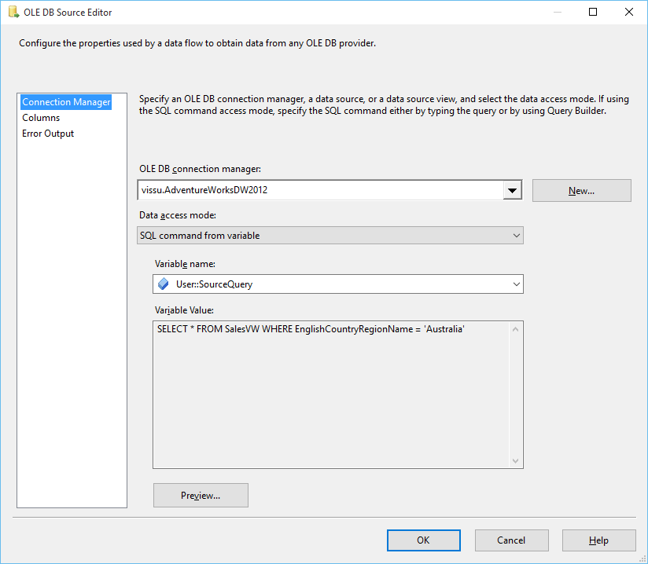
Destination Configuration:

Drag a follow-up flat destination to the above row count transformation, and choose the destination as. Choose the dynamic expression for the flat file connection as

Expression:
@[User::FullFilePath]

Static Path for Flat file destination connection is as follows

Path:
D:\Desktop\MSBI\SSIS\Files\Flatfiles\DailySalesDetails\Sales_20161022\Australia_20161022.txt

The finalized ETL task 1 screen shot is as follows

Finalized ETL screen shot
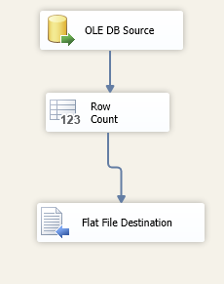

Close TaskID
Drag an execute SQL task name it as close TaskID. Used in the package 10 design document

Task-2 (Flat file to OLAP_DB )

Open TaskID
Drag an execute SQL task name it as Open Task Used in the package 10 design document

Mapping steps for Task-2
Drag and drop a Data flow task, and choose “FlatFile Source” and “OLEDB” type destination.

Source Configuration:

Configure the Flat File source as from ETL task1 same here.

Destination Configuration:

Drag and drop an OLEDB destination. Choose vissu.OLAP_DB. Choose the data access mode as “Table name or view variable”, and then map the “DestnationTable” variable.

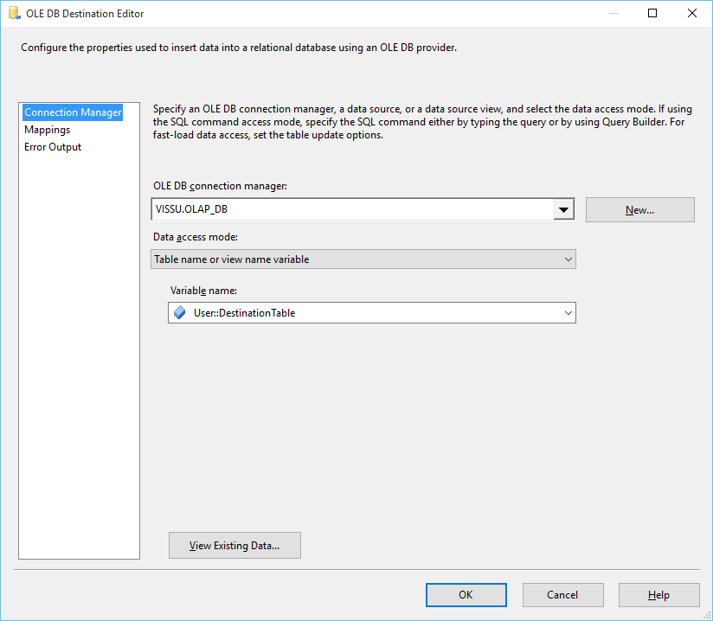

The finalized ETL Task 2 is as follows

Finalized ETL screen shot
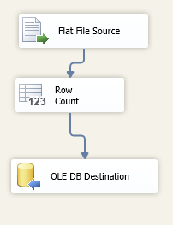

Close TaskID
Drag an execute SQL task name it as Close Task1 Used in the package 10 design document

Close BatchID
Drag an execute SQL task name it as “Close Batch” Used in the package 10 design document

Finalized Package screen shot

